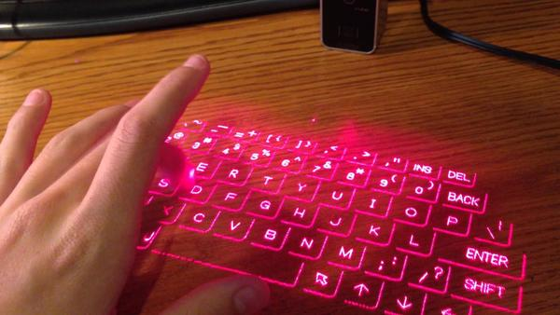**Bluetooth Wireless Laser Projection Virtual Keyboard:**

**1-History:** Who invented the virtual keyboard?

An optical virtual keyboard was invented and patented by1 IBM engineers in2 1992. It optically detects and analyses human hand and finger motions and interprets them as operations on a physically non-existent input device like a surface having painted keys. Apart from simply being used to type, some1 laser keyboard systems have few2 new functions as a virtual mouse or even as a virtual piano.

This invention made a qualitative leap in the field of technology, which increased the number of investors in the sector and resulted in many promising future ideas, among them: making the keyboard a virtual form inside3 the glasses.

But nothing in this world is without defects, so our device displays a full-size QWERTY keyboard, which typically contains 60 or more keys. Then you simply type just like you would on a normal keyboard, although the sensation you normally get when typing on a laptop or desktop -- the pops and clicks associated with the keystrokes punching up and down -- won't be there. In fact, it takes a little bit3 of practice for many users to become accustomed to pressing their fingers on a smooth surface.

**Three forms of preposition: (They are with Red in the article. )**

1. by1: Preposition for Agent .
2. in2 : Preposition of time .
3. inside3: Preposition of place.

**Three Quantifiers: (They are wirh Green in the article .)**

1. some1 : Example of Quantifiers for both countable and uncountable nouns.
2. few2 : : Example of Quantifiers for Countable Nouns .
3. a little bit3: Example of Quantifiers for Uncountable Nouns.

By : KHITER Mohamed Achraf.

L2 , Section B, G03